The ECEP server is used to interact with nodes. ECEP server also supports a web GUI (based on tornado framework) using which nodes can be created, deleted and managed. In order to setup the server please install below dependencies.

Install Crossbar.io on server machine as follows:

1. After a fresh of Ubuntu 16.04 LTS 64-bit Server, first make sure your system packages are fully up to date:

*sudo apt-get update*

*sudo apt-get -y dist-upgrade*

1. Then install the prerequisites:

*sudo apt-get -y install build-essential libssl-dev libffi-dev *

*libreadline-dev libbz2-dev libsqlite3-dev libncurses5-dev*

1. After the [prepare-step](http://crossbar.io/docs/Installation-on-Linux/#prepare), build Python from vanilla sources and install it to your home directory:

*cd $HOME*

*wget https://www.python.org/ftp/python/2.7.13/Python-2.7.13.tar.xz*

*tar xvf Python-2.7.13.tar.xz*

*cd Python-2.7.13*

*./configure --prefix=$HOME/python2713*

*make*

*make install*

1. Install [Pip](https://pypi.python.org/pypi/pip) and make sure it is the latest version:

~/python2713/bin/python -m ensurepip

~/python2713/bin/python -m pip install -U pip

1. Install Crossbar and its dependencies from [PyPI](https://pypi.python.org/pypi/crossbar):

~/python2713/bin/pip install crossbar

1. Check the Crossbar installation:

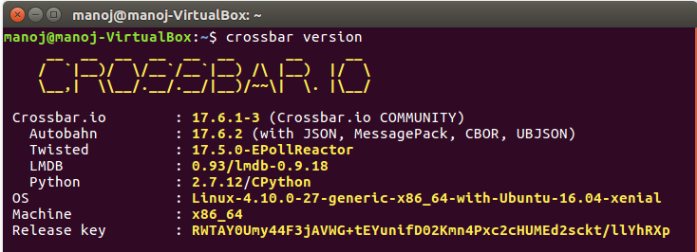

1. Clone the ecep server side code from our google drive.

<https://drive.google.com/drive/u/1/folders/0B28zc8utiaqLc1lGMUZieWRuUlU>

1. Start crossbar inside ecep_wampServer by entering below command:

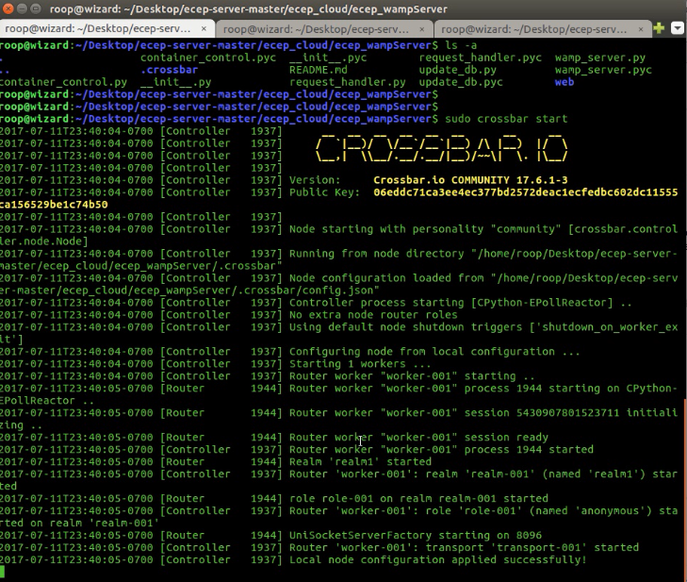

1. Once the server is up and running we need to run the script (ecep_server.sh) to start the ECEP dashboard.

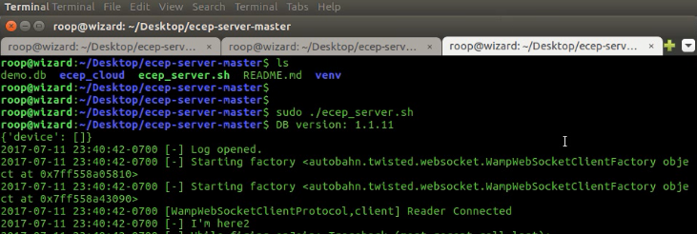

1. Access the ECEP dashboard via the localhost.

